Lab 1 Report

### Data Structures

Chad Lape

# Objectives and Concepts:

The Lab had followed some basic ideas of programming regarding variable management, debugging, and recursive renaming. Variable management is seen through the 2nd task where the original creator had accidentally switched how their array worked midway through the code. It is important to the course and a career in CS as when variables are being used, proper management will help large numbers of variables remain consistent throughout the program and be more organized. Debugging is the process of finding errors within code and fixing them. it is important to be efficient at this within this class and the larger CS career as the process of debugging often takes a lot of time and reducing smaller mistakes will help reduce that time it takes. Finally, renaming recursively is the process of changing the names or, in this case, the types of variables used and then going through the rest of the program files used to change those names and types used to keep the program consistent. Not doing this would lead to syntax errors through the program as it attempts to reference a name which no longer exists if it has been changed.

# **Task 1:**

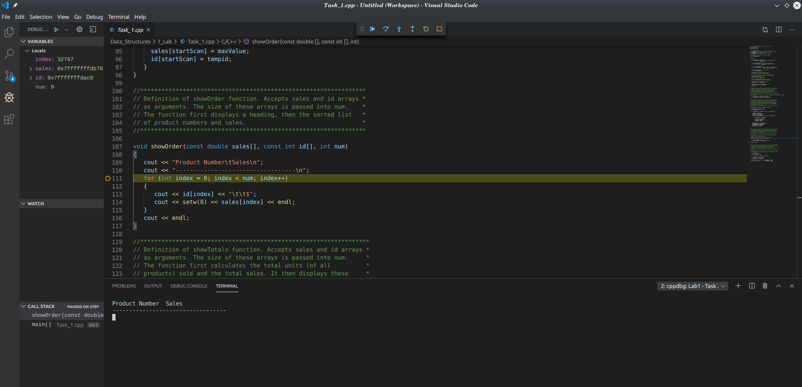*This shows the use of a breakpoint at line 41 and then stepping through the program until two lines of text had been outputed.*

## Task 2:

To debug lab 2 I had first ran the program to get an idea on what it was supposed to do and then looked at the comments to see how those described the program as working. Afterwards I had then looked through the program to see if I could catch any obvious mistakes and find what the structure of the program was, I fixed the issue of outputting only Division 4 during this time. Finally I went through the program in debug mode to monitor the variables and found the other bugs during this point.

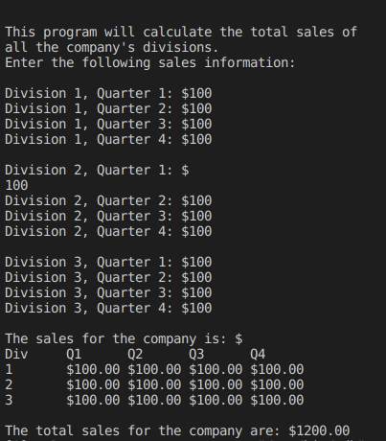Showing corrected Task 2 output

The bugs in this program are all logical errors consisting of small problems due to variable mismanagement and by the programmer not fully remembering which variable is which. The programmer could avoid these mistakes by remembering their naming standards and being careful when using their variables.

## Task 3:

For task 3 we had to create a struct to replace the data which was being manipulated which was data on different products: ID, units sold, product price, and the total sale number. Thus I created a structure calle Product with 2 ints and 2 doubles arranged in the order above. This done as in the main, I create an array of the structure Product and fill it like a 2 dimensional array, without filling the sale value. Then I comment out the original array and rename the array calls to calling for the product array attributes ie. sales[i] → products[i].sales. After doing this for the whole file and then changing the function arguments to getting only the product structure. For computing the sales there had initially been thought to be an error but the default way to call and array seems to be a pass by reference which meant the sales attribute could be changed directly and would not need to have anything extra done to it other than directly changing the value.

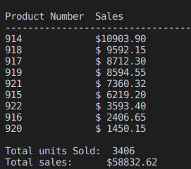  
Showing the correct Task 3 output which is identicle in function to task 1